ASP.NET Core 8.0 Web API

2. Web API Hands on

1. Objectives
- Demonstrate Swagger installation and Web API listing in the browser using Swashbuckle.AspNetCore, Swagger configuration and Swagger UI.
- Demonstrate the use of Postman to test Web API methods, including GET requests, response body and HTTP status.
- Demonstrate the use of Route attributes and change a controller route to a user-friendly route.
- Demonstrate creation of a simple Web API with Read and Write actions.

2. Software / Tools Used
- Visual Studio
- ASP.NET Core Web API
- C#
- Swashbuckle.AspNetCore NuGet package
- Swagger UI
- Postman
- Web Browser

3. Procedure

3.1 Swagger Configuration
The existing ASP.NET Core Web API project ApiLab1 was used. The Swashbuckle.AspNetCore NuGet package was installed through the NuGet Package Manager Console. Swagger was configured in Program.cs using AddSwaggerGen(), UseSwagger() and UseSwaggerUI().

3.2 Execute and Verify Swagger
The application was executed and the Swagger UI was opened using the local Swagger URL. The API controller and its HTTP verb action methods were displayed. The GET action was expanded, Try it out was selected, and Execute was clicked to verify the response.

3.3 Test Employee GET Method Using Postman
An EmployeeController was created with a GET action method. The local Web API was started and the Employee GET endpoint was accessed using Postman. The response body displayed the list of employees and the HTTP response status was verified as 200 OK.

3.4 Modify the Employee Controller Route
The route of the EmployeeController was changed from the default controller-based route to the user-friendly route api/Emp. The updated endpoint was accessed through Postman and the employee list was successfully returned with a 200 OK response.

4. Important API Configuration / Code
Swagger service registration:
builder.Services.AddSwaggerGen();
Swagger middleware:
app.UseSwagger();
app.UseSwaggerUI();
Employee controller route after modification:
[ApiController]
[Route("api/Emp")]
public class EmployeeController : ControllerBase

5. HTTP Methods Demonstrated
HTTP Verb | Purpose | Attribute
GET | Retrieve or read data | [HttpGet]
POST | Create or submit data | [HttpPost]
PUT | Update existing data | [HttpPut]
DELETE | Delete data | [HttpDelete]

6. Screenshots
Figure 1: Swashbuckle.AspNetCore NuGet pa ckage successfully installed.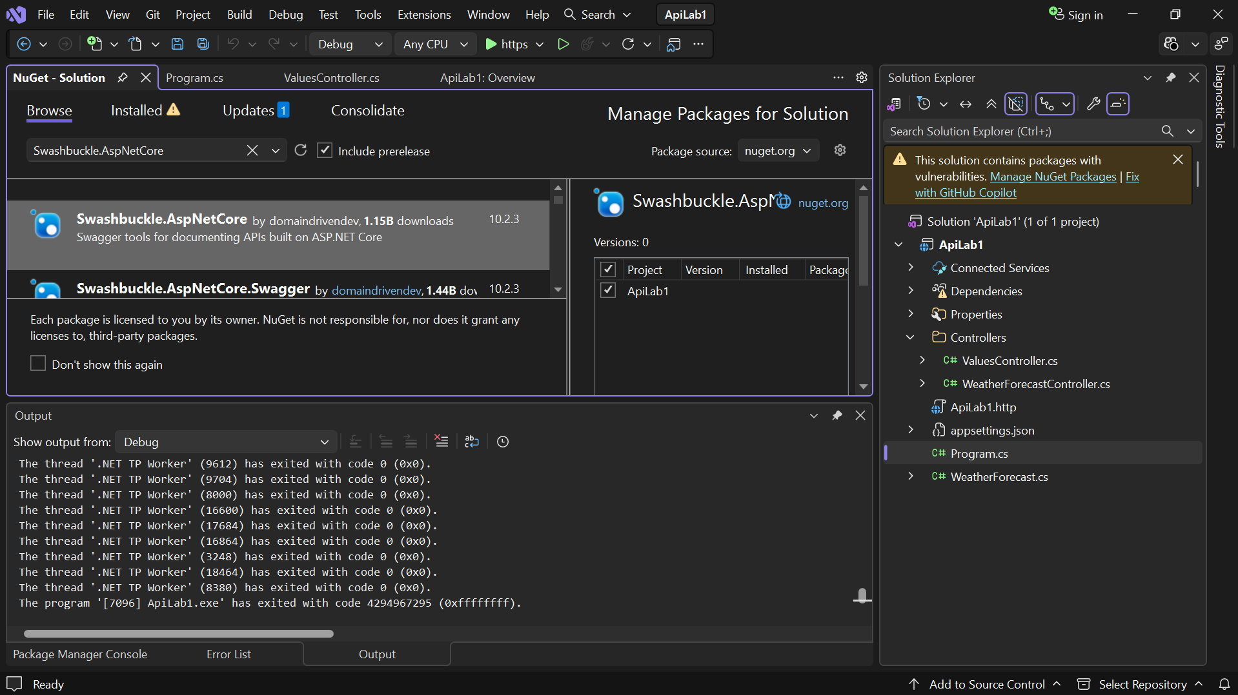
Figure 2: Swagger UI displaying the Web API controller and HTTP verb methods.
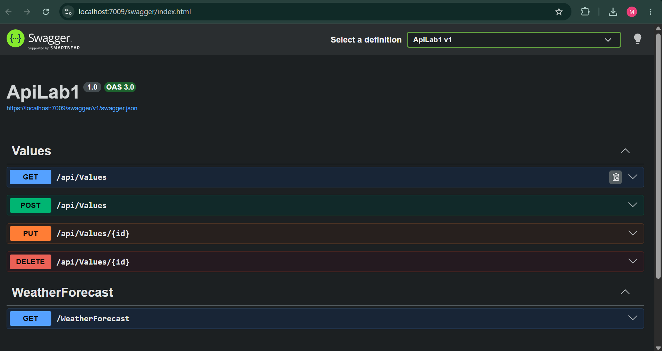

Figure 3: Swagger GET method executed using Try it out and Execute, showing the response.
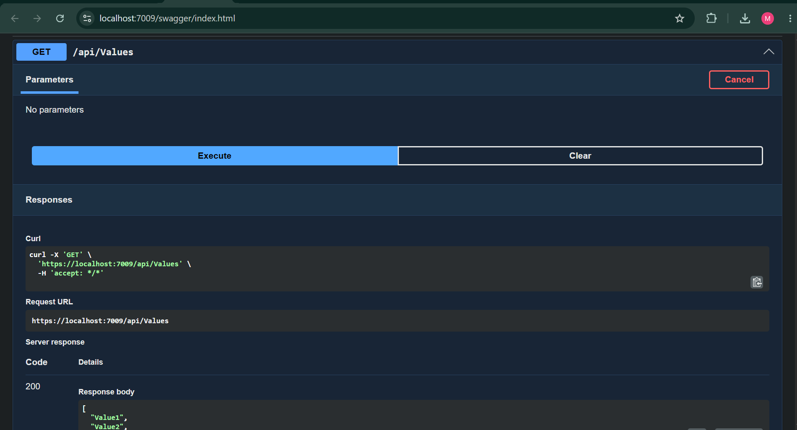
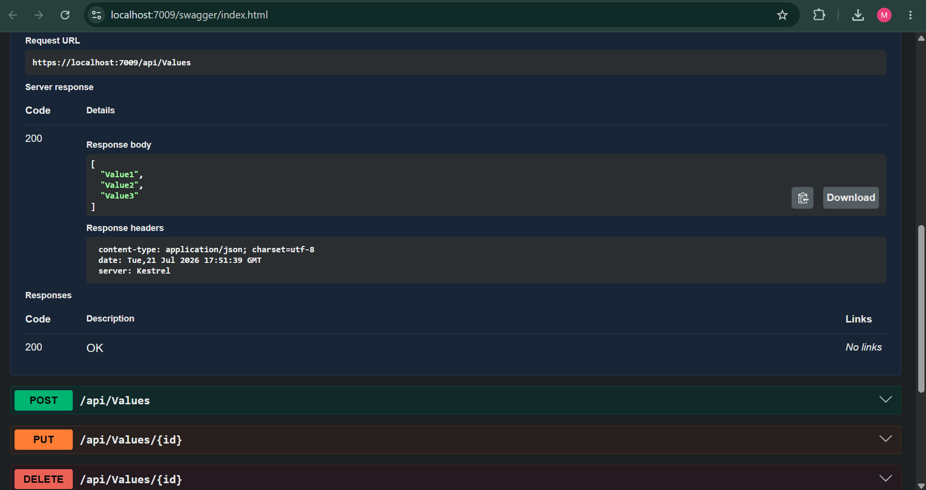

Figure 4: Postman Employee GET request showing the employee list in the response Body and 200 OK status.
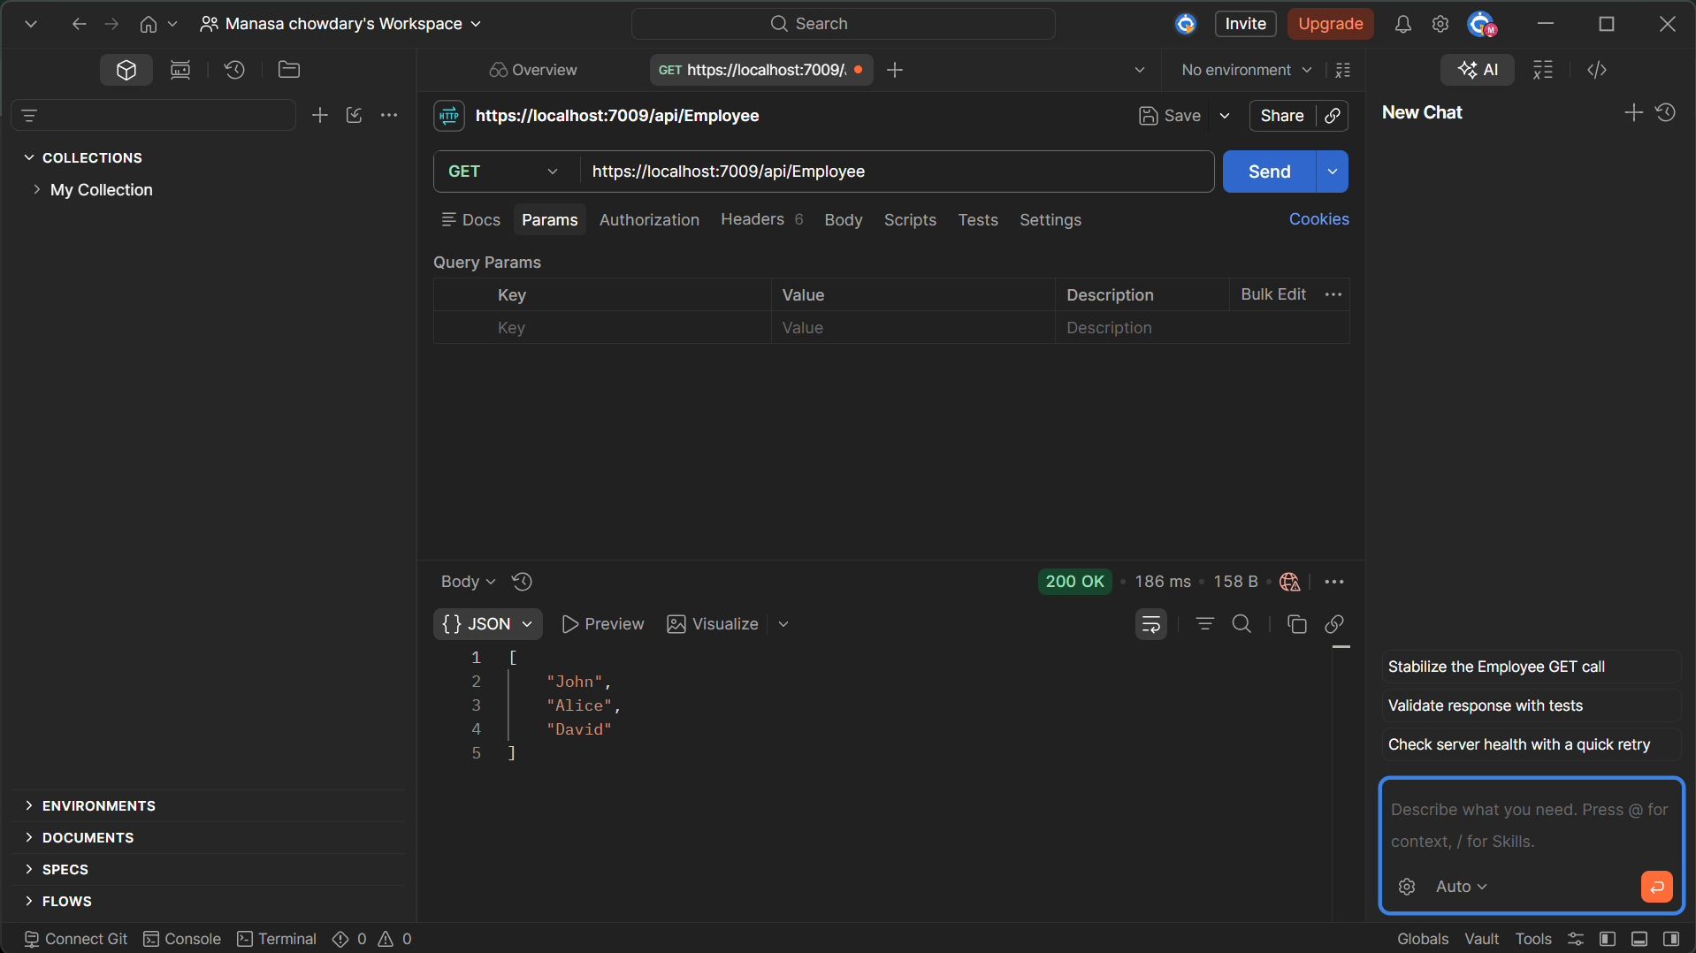
Figure 5: Postman request using the modified api/Emp route showing the employee list and 200 OK status.
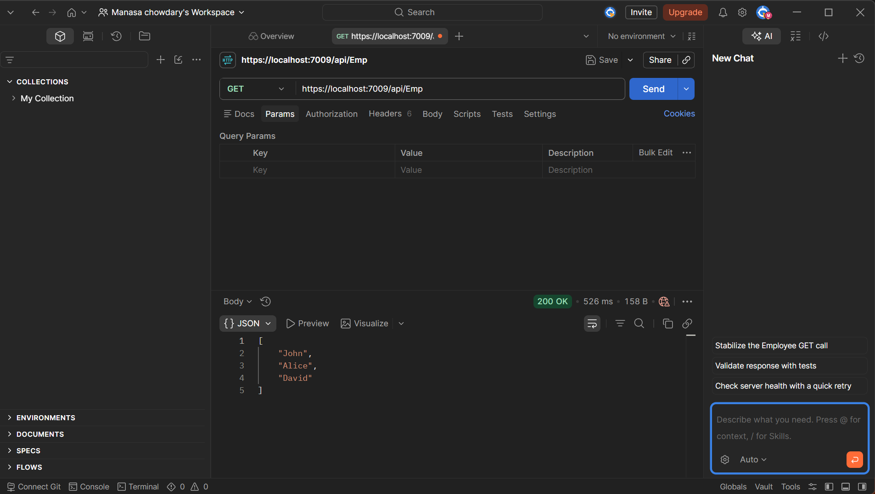

7. Result
Successfully installed and configured Swagger for an ASP.NET Core Web API and verified the API endpoints using Swagger UI. The Employee GET method was successfully tested using Postman, and the employee list was displayed in the response body with a 200 OK status. The Employee controller route was changed to api/Emp and the updated endpoint was successfully accessed through Postman.

